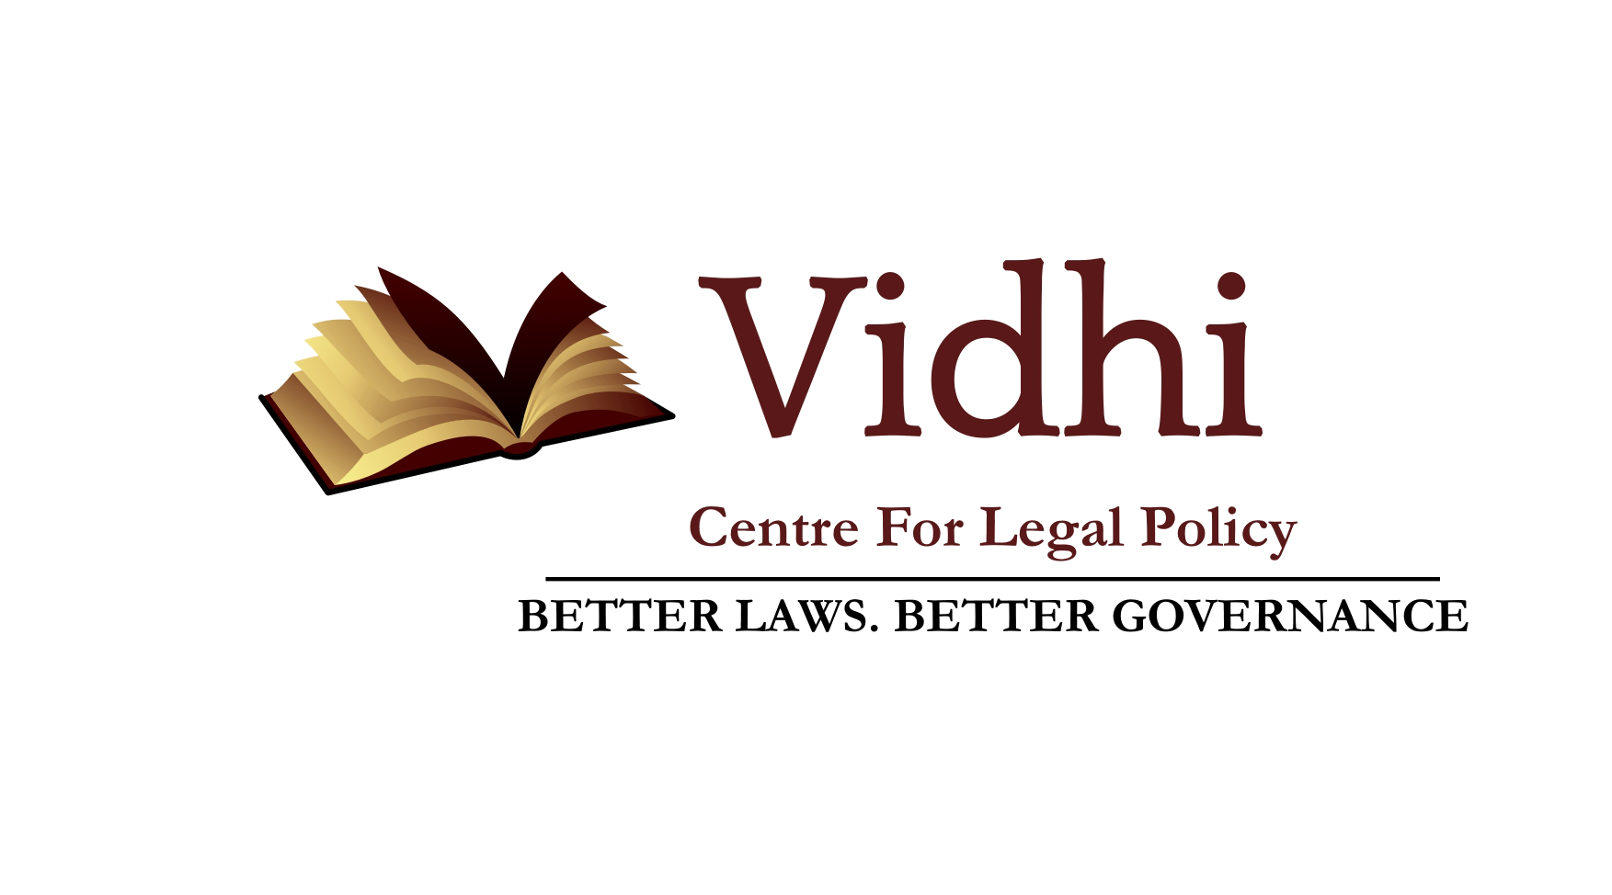 | 

The Takshashila Institution and the Vidhi Centre for Legal Policy release a report on countering mobilised violence at the Bangalore office of the Takshashila Institution

Bengaluru, November 2018

The Takshashila Institution and the Vidhi Centre for Legal Policy will release the report, “A Framework for Countering Mobilised Violence” in an event at the Bangalore office of the Takshashila Institution on 5 December, 2018, at 6.00 pm. Mr. Udaya Holla, Advocate General of Karnataka, will deliver the keynote address.

The unveiling of the report will be followed by a panel discussion on Mobocracy - Combating Organised Violence in India. The panelists for the event are:

Dr. Aditya Sondhi, Senior Advocate
Mr. R. Srikumar, Former DG, Karnataka Police, and Former Vigilance Commissioner
Dr. Vikas Kumar, Azim Premji University

The report suggests legal measures to enable state institutions to address the problem of collective violence which is driven by political agendas. Such violence prevents people from enjoying their right to speak, move and conduct business freely, a necessary component for making collective political decisions. It can also result in injury and loss of life to bystanders, in addition to significant economic costs from a cessation of economic activity and damage to property.
Existing legal measures have proved insufficient as incidents of mobilised violence continue to occur. While some laws aim to address mobilised violence by imposing restrictions on hate speech and the formation of associations or assemblies, they tend to be poorly drafted. The resultant discretion that this gives to the State is wide and prone to abuse.
The report recommends an overhaul of existing legal mechanisms under the criminal justice system to address these issues, including:
- Focussing on regulating violent group activity and holding groups and their leadership accountable for the same, without criminalising group membership and reducing executive discretion in regulating assemblies;
- Reforming hate speech laws to reduce arbitrariness while penalising incitement to violence;
- Empowering the National and State Human Rights Commissions to act as mobilised violence observatories for observing, disseminating, and analysing data on mobilised violence;
- Appointing a special public prosecutor for cases related to mobilised violence to increase transparency and accountability;
- Reducing executive interference in the criminal justice system by reforming procedural laws.

A copy of the report will be available shortly after the event. For a media pass or an invitation to the event, please write to divij.joshi@vidhilegalpolicy.in.

