NATIONAL SEMINAR
on
“EMERGING ISSUES IN LAW & JUSTICE IN THE PERSPECTIVES OF GLOBALISATION”
Organised by
Committee to organize seminars, workshops, extra-mural and special lecture
of
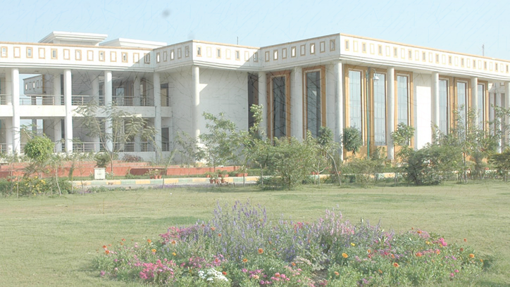
Dr ram manohar lohiya
national lawuniversity
lucknow
28th–29th March, 2020

Concept Note
  - Globalization has shrunk the world into a global village. It has made countries interdependent on each other such that not only economic system, but political, legal and social system have also become intertwined with each other. Meaning and dynamics of justice have been evolving overtime and new dimensions of human wants, rights, equality and deprivation have been added to the narratives of law and policies.
  - Globalization encompasses not only economic dimensions but also political, cultural and social spheres too. Political narratives have metamorphosed from national sovereignty to transnational political organizations, from fundamentalists to newly energized international human rights. Moving from the issues of mass production, trade unionism, industrialization and manufacturing technologies, the liberalized era calls for niche production, flexible labor laws, declining trade unionism and increased female labor force participation. However, in these changing paradigms, it becomes worthwhile to analyze if justice has also evolved and undergone a metamorphosis. There are several legal challenges being thrown up with these changing socio-economic changes. From rigidities of labor market , we are moving towards flexible and adjusting labor laws and policies; the development of supra-national institutions such as United Nations, WTO, European Nations, ILO, NATO, ASEAN have created international rules and policies and they also determine which issues and agendas have to be brought to the center stage at international level. The narratives for equality and justice have also been broadening and widening wherein new ideas of deprivation and capabilities have been adding up to the issue of age-old problems of poverty and inequalities.

About the Seminar
  - With increasing trade and investment across borders there is a need for adjusting the processes of multilateral policy making and dispute resolutions while at the same time aligning them with our domestic legal processes and machineries. In these changing scenario themes related to international trade law, investment law, comparative constitutional law and international dispute resolution have been gaining prominence. However, the collapse of several international political and economic institutions, there is a need for strengthening our current domestic legal and regulatory mechanisms before shifting to multilateral negotiations and supra national policies. In these changing paradigms, the issues of compensation, rehabilitation, dispute resolution, human rights, pervasive inequality on the basis of caste, class, region, religion and sex, need adequate attention and focus.
  - The aim of this seminar is to analyze these changing dimensions of justice and law and to brainstorm through various research papers and academic discourses as to how these narratives can be given right direction so that justice- political, economic and social can be ensured and the idea of Inclusive Growth, Development and Justice may be actualizedin this era of globalization.
  - The Seminar calls for papers under following sub themes, however the list is only indicative and not exhaustive. Any other topic related to the Seminar theme may also be submitted.

Sub Themes
- Challenges created by Globalization and issues of economic, political and social justice.
- Conceptualization of Justice by political, social and economic thinkers.
- Administration of Justice and access to justice.
- Changing perspectives of human rights in the light of globalized world.
- Multilateral agreements and its impact on domestic legal frameworks.
- Labor market and movement towards increased flexibility in labor laws.
- Increasing internationalization of IPR laws and threats to indigenous intellectual property of nations.
- Deprivation, inequality and issues related to economic opportunities
- Democracy and political opportunities to masses; free and fair elections.
- Conflicting issues of Growth vs Sustainable Development; national and international perspectives.
- Reservation Policy and its rationale in the liberalized world.
- Gender issues and ideas of justice as envisaged in the constitution; issues of safety of women and marginalized sections and our current legal system.
- Rights of Minorities and laws pertaining to it.
- Citizenship laws and the rights of refugees.
- Mental health and the rights of mentally ill patients.
- Psychodynamics of crime and perspectives on criminal laws.
- Corporate Governance and the interests of shareholders, consumers and workers.
- Competition Law and other Government regulations related to unfair and restrictive trade practices.
- IPR, Farmer’s Rights and Agrarian Laws in India.
- Bilateral Economic and Political treaties and their effects on domestic policies.
- WTO and issues of level playing field between developed and underdeveloped nations.
- International Institutions and their encroachments to indigenous policy mechanisms.
- Comparative analysis of international law in matters related to human rights, cross border business, environment labor and other global concerns.
- Cross border terrorism and international law.
- Right to education and compulsory
- Issues, problems and laws concerning LGBTQ persons in India.
- Constitutional protection and legislative safeguards for child rights.
- Internationalization of legal education.

Call forPapers
  - University invites well researched and authentic research papers, case analysis, articles by Academicians, Policy makers, Journalist, Lawyers, Bureaucrats, Research scholars and Students. Research papers shall be subject to the approval of Editorial Board for inclusion in the seminar.

Submission guidelines
- All submissions have to be in English.
- The abstract should not be of more than 300 words. It shall contain- a brief profile of the author including e-mail ID, contact number and official address.
- Word limit for full Research Paper- 4000-6000 words (inclusive of all citation and references).
- Submissions must be typed in Times NewRoman, Font Size 12 on A4 size paper with 1” margin on all sides with 1.5 line spacing.
- There can be maximum of only one Co-author. All the co-authors need to get registered for the seminar.
- Potential contributors are required to adhere to a uniform mode of citation (20th edition of The Bluebook: A Uniform System of Citation or ILI Citation is recommended).
- The authors should also send a declaration along with the abstract & final paper that their work is original and unpublished and that it does not infringe the copyright laws. The organising committee is not responsible for any copyright infringements by the authors.
- Participants who intend to present their research papers in the seminar are required to submit the Abstract on or before15th February, 2020through e-mail to seminarrmlnlu2020@gmail.com.
- Full papers need to be submitted by 5th March, 2020.
- The accepted full research papers may be published in the form of an edited book.
- The registration fee which includes registration kit, lunch and tea is as follows:
- For students- ₹1000/-
- For academia and professionals - ₹2000/-
- RMLNLU faculty & students- No fee
- Registration for the seminar has to be done through the following link:- https://forms.gle/Yw6AkXh27oo7Faou6
- Payment Guide:
- Proceed to the following link: https://www.onlinesbi.com/sbicollect/icollecthome.htm?corpID=288415
- Select registration fee.
- Select Seminar/Workshop in the event tab and fill the required details.
- Proceed with payment and after successful payment, kindly upload the receipt in the registration form
- Accommodationshall be provided as per availability on payment basis.

••• CHEIF PATRON•••
Prof.Subir K Bhatnagar
Vice-Chancellor, Dr.RMLNLU

••• Patron •••
Prof. (Dr.) CM Zariwala  Dean, Academics, RMLNLU | Dr.VisalakshiVegesna  Head of Department, RMLNLU

••• ORGANISING SECRETARY •••
Dr.Prem Kumar Gautam | Dr.Mitali Tiwari

••• ORGANISING COMMITTEE•••
Dr. (Mrs.) Alka Singh | Dr. Abdullah Nasir
Mr. BhanuPratap Singh | Ms. PriyaAnuragini

••• student coordinatorS•••
Ahmad Sulaiman  Convenor | YaqoobAlam  Co-Convenor |  | AniketSachan  Co-Convenor
Sakshi Agarwal  Secretary |  | Kumar Harshit  Treasurer
For any further clarification mail us at seminarrmlnlu2020@gmail.com

