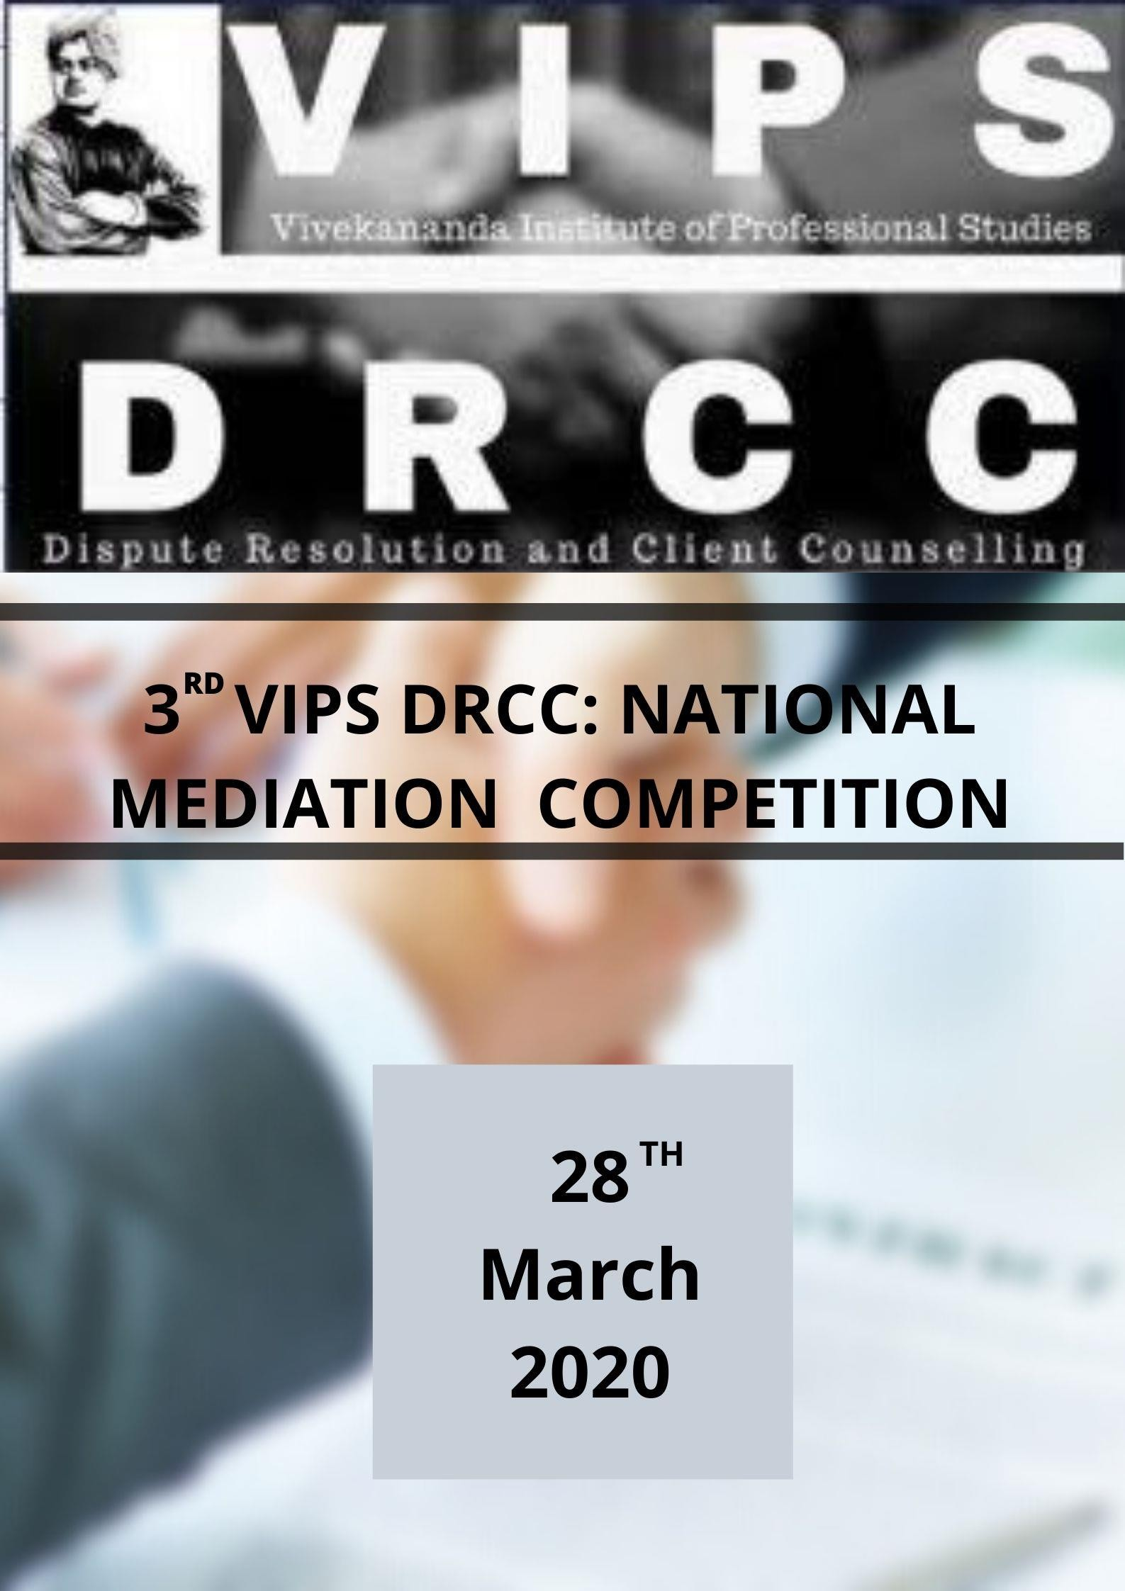
3rd VIPSDRCC: NATIONAL MEDIATION COMPETITION
28th March 2020 Delhi Email-
India vipsdrcc@gmail.com

Rules and Regulations | 01

“SETTLE NOT SUE”

The Competition

Aim and Purpose

Eligibility
These rules shall regulate all aspects of the 3rd VIPS DRCC National Mediation Competition (hereinafter referred to as “the Competition”) 2020, organized by Vivekananda School of Law and Legal Studies, VIPSDRCC (hereinafter referred to as the Organizing Committee).

The Competition will be held at Vivekananda Institute of Professional Studies on 28th March, 2020.

Mediation is a voluntary, party centered and structured negotiation process where a neutral third party assists the parties in amicably resolving their disputes by using specialized communication and negotiation techniques. The goal of mediation is to find a mutually acceptable solution that adequately and legitimately satisfies the need, desire and interest of parties.

The Competition is open to all bona fide students pursuing undergraduate degrees (five and three-year law courses) in law Schools/Colleges/Institutions/Universities only in India (hereinafter “Participating Institution”).
Each Participating Institution is permitted to send a maximum number of two teams
in the Competition which will be further subject to First Come First Serve basis.

All Participants must be registered with respective institutions as full-time or part time students for the academic year 2019-2020.

Structure

TEAM COMPOSITION
- Each team shall comprise of three students consisting of one Mediator and two team members acting as the client-counsel pair (referred to as the “Mediating pair”).
- One member of the team will be designated as Mediator, whose role shall remain unchanged throughout the Competition. The other two members of the team will form the Mediating pair, representing a Client and his/her Counsel. The respective roles though not interchangeable within a round, are changeable in different rounds.
- The two mediators in one competition session (from different teams) for all purposes will be referred to as Mediator 1 (M1) and Mediator 2 (M2) as designated in the match-ups.

COMPETITION STRUCTURE
- Two Teams (Two Mediating Pair) will be the Requesting and Responding Parties respectively. The Mediating pairs and Mediators for each Session and their roles shall be decided by draw of lots.
- Each round will have members from four different institutions (four members of two teams forming two Mediating Pair and two Mediators from different institutions). To avoid any conflicts, the Mediators will not be assigned to those sessions in which Mediating pairs belongs to the same Institution as that of the Mediator.

ROUNDS

PRELIMINARY ROUND
- The competition will have one preliminary round for a period of 35 minutes (exclusive of the preparation time provided for 15 minutes prior to the session). Followed by a post analysis session with the judges for a period of 5 minutes during which the members of all the teams will receive feedback and comments from the judges regarding the session while discussing their BATNA and mediation strategy.

QUARTER FINALS
- Eight teams selected from the preliminary rounds on “Knock- Out” basis will qualify for the quarter finals which will be for a total period of 45 minutes (exclusive of the preparation time provided for 15 minutes prior to the session). Followed by a post analysis session with the judges for a period of 5 minutes.

SEMI FINALS
- The four teams qualifying for Semi-Finals will be selected on a “Knock- Out‟ basis from the quarter finals rounds. The Time limit of the Quarter Finals will be 45 minutes (exclusive of the preparation time provided for 15 minutes). Followed by a post analysis session with the judges for a period of 5 minutes.

FINALS
- The teams selected for finals on a “Knock-Out‟ basis from the Semi-final rounds will compete in the Finals for a total time period of 60 Minutes (exclusive of the preparation time of 20 minutes prior to the competition session) followed by a 10 minutes post analysis session.

CONFIDENTIAL INFORMATION
- Each Mediating Pair will be provided separate Confidential Information 15 minutes before the start of each session which will be their Preparation Time, except for the Final Rounds where a team will be given 20 Minutes Preparation Time. The Mediator however will not be provided any Confidential Information.
- The Mediating pairs and the Mediators will not be permitted to have any contact or communication whatsoever with each other once the Confidential Information has been provided to the mediating pair.

CAUCUS
- The Mediator may conduct a private session, (Referred to as a “Caucus‟) with each of the Mediating pairs. A Caucus may be called by either the Mediating pair or the Mediator. The Mediating pair which is not part of the Caucus will be required to leave the room during that time.
- A Caucus may be for a maximum of 5 minutes. The Mediator and the Mediating pair, both, will be responsible for managing and adhering to their time limit. Failure will result in penalty at the discretion of Judges and the Organising Committee. This is inclusive of the time limit provided for the session.
- Caucuses can also be held between the Mediator and the Clients of both Mediating pairs or the Counsel of both Mediating pairs (“Cross-Caucus”).
- The Mediator and Mediating pairs will be scored by the Expert Assessor (Judges) on the appropriateness of each Team to call or not to call for a Caucus.

BREAK(S)
- Each Mediating pair and the Mediator may request for a single 2-minute Break during each session. The Team requesting the break will be responsible for adhering to the time limit. Failure will result in a penalty, as deemed fit by the Organizing Committee.
- Where a Mediating pair asks for a Break, the members of the said Mediating pair requesting the Break will be required to leave the room.

LANGUAGE
- All Competition Sessions will be conducted in English. The Member (client and counsel) of the same team are allowed to speak in other languages during their breaks but only amongst themselves. They cannot converse with the mediator or the other team in any other language, besides English. However, the parties are free to use any other language whilst discussing something with a fellow team member.
MATERIAL
- No outside material whatsoever, including the any access to internet will be permitted when the round is in progress for any participants in the round, but not before the commencement and after the ending of rounds. Any violation of the rule will lead to immediate disqualification. Students are allowed to bring their own books and stationery.
- Teams are permitted the use of materials supplied by the Organizing Committee, personal notes and stationery items. (Teams may also bring one single-side printed A4/letter sheet to share with the other participants, the Mediator and the Expert Assessors.)
- No electronic equipment such as phones, tablets and laptops may be used during the Session by any acting member of any Team. Students are encouraged to bring calculators and watches or other dedicated timing devices. Phones or other electronic equipment are not allowed to be used

during the Sessions for time-keeping, calculating, etc. Electronic equipment cannot be brought to a Break or Caucus.

DRESS CODE
- The dress code for the competition will be business formals. All the participants are required to adhere to the dress code.

COMPETITION PROBLEMS
- The organizing committee will be releasing the problems of all the rounds of the competition in advance, on, 18th March, 2020 subject to any change in the schedule, which shall be notified through the Official Facebook Page of the of the competition.

Judging Criteria

MEDIATING PAIR

- Statement of parties
- Constructive Approach
- Creating a conducive atmosphere
- Caucus
- Teamwork Between Advocate and Client
- Characterization and authenticity
- Use of Confidential information
- Effective utilization of the services of the mediators
- Body Language Judicious utilization of the time

MEDIATOR

  - Opening Statement of the Mediator
  - Co-operation Between Mediators
  - Caucus
  - Identification of Issues and Option Generation
  - Qualities of a Mediator
  - Control of the Mediation Session
  - Question framing
  - Nonverbal communication
  - Closing Statement
  - General Performance

Results

- Expert Assessors (Judges) will be selected by the Organizing Committee to score the performance and provide feedback to the students to help them move through the Competition rounds.
- Throughout the Competition, the Mediating pairs and Mediators will be evaluated and scored separately and will advance in the competition independently of each other.
1) Co-operation Between
Mediators
- The timings and the venue for the announcement of results of each competition round will be intimated to the teams in advance and the teams are expected to present themselves at the designated time and venue.

Awards 28. The following is a list of the awards that will be presented to the teams.

Best Team
Winner’s Trophy
Cash Prize: Rs. 10,000/- Certificate of Merit

Runners up Team Runners up Trophy Cash Prize: Rs.7,500/- Certificate of Merit

Best Mediator
Best Mediator Trophy Cash Prize: Rs. 5,000/- Certificate of Merit

Best Mediating pair Winner’s Trophy Cash Prize: Rs. 5,000/- Certificate of Merit

Runners up Mediating pair

Trophy
Certificate of Merit Certificate of Merit Quarter Finalists,
Semi-Finalists and Finalists Other Participants Certificate of Participation

Rules and Regulations | 08

Registration
Procedure 29. A team is required to register by completing the registration form annexed
herein and thereafter sending a scanned copy of the Registration form filled, duly signed and stamped by the Head of Institution/Principal/Head of Department along with the Demand Draft (DD) of Rs. 2000/- in favor of Vivekananda Institute of Professional Studies, payable at Delhi, at vipsdrcc@gmail.com with the mail marked as “REGISTRATION- 3RD VIPSDRCC: National Mediation Competition”. The Last Date of Team Registration is 29th February, 2020.

- Participants can also submit registration fee (i.e. Rs. 2000/-) via NEFT, in case participants opt for the same, proof of completion of transaction including the following details must be send with the soft copy of registration form at vipsdrcc@gmail.com
  - Name
  - UTR no./Reference No.
  - Amount
  - Date

- To complete the process of Registration, the hard copy of the Registration Form along with the Demand draft must be sent (by Post or by hand) to the following address latest by 29th February, 2020.
The Dean, Vivekananda School of Law and Legal Studies,Vivekananda Institute of Professional Studies, AUBlock, Pitampura, Delhi-110034 Phone: +91 (11) 26343401, 26343402
Further, any delay in such submission shall be considered only on case to case basis.

Mediation

Rules and Regulations | 09

- Bank Details for Demand Draft and NEFT

NAME: VIVEKANANDA INSTITUTE OF PROFESSIONAL STUDIES BANK: AXIS BANK LTD.
BRANCH: LOK VIHAR ACCOUNT NO.: 910010004295801 IFSC CODE: UTIB0000588

Code of Conduct

Clarifications

Interpretation
- Participants are to conduct themselves with the required etiquette during the span of the entire competition. Reckless or irresponsible behaviour by any of the team members of an institution may result in the disqualification of the entire team.
- All or any grievances are to be presented only to the organizing committee of the Competition and the decision of the Organizing Committee will be final.
- Participants shall not reveal their personal identities or that of their University to any judge or participant during the course of the competition.
- Any attempt to obtain the Confidential Information shall render a team liable for immediate disqualification.
- Failure to adhere to any of the time limit will result in a penalty against whomsoever the delay is attributable to. The penalty will be decided by the Judges /Organizing Committee.

- The Participants may seek Clarifications regarding any aspect of the Problems. Rules or Procedure vide a mail at vipsdrcc@gmail.com latest by 21st March, 2020.

- Any question regarding the interpretation any provision of this rule shall be subject to the decision of the Organizing committee and any decision made by them thereon shall be final.

Mediation
Rules and Regulations | 10

Rules applicable
- In case where marks of two or more teams are same, then marks of the constructive approach of the mediating pair will be taken into consideration.
Further, in case construction approach marks are same, then marks of identification of issues and option generation, will be seen.
Further, in case those marks are also same then marks of question framing will be the deciding factor.

Accommodation

Contact Us

- For accommodation
Email: - vipsdrcc@gmail.com (subject as Accommodation)

Sparsh Goyal +91-9717762025
Vansh Vermani- +91-9717734035

- For any further clarifications questions or queries the participants may feel free to contact any below mentioned –

Student Convener: Vansh Vermani +91-9717734035 Student Co-Convener: Vritti Gulati +91 -9897772479
Member: Divij: +91-8585955902

REGISTRATION FORM

VIPSDRCC MEDIATION COMPETITION

(Fill in Block Letters)
M E D I A T O
R

INSTITUTION DETAILS:
Name:

Address:

PARTICIPANTS DETAIL:
N A
M

- Mediator

Name Year Phone No.
Email

Mediating pair
N
A M

  - Name:
Year:
Phone No.:
E-mail:

  - Name:
Year:
Phone No.:
E-mail:

Faculty Incharge Head of the Institution
(Signature with Institutional Seal) (Signature with Institutional Seal)

Details of Demand Draft Details of NEFT

DD NO. BANK ISSUING DD

REFERENCE NO. NAME & ACCOUNT NO.

We the undersigned declare that the institution and its team members will abide by all the rules of the competition set out as official and as notified to us from time to time throughout the period of the competition. We also declare and confirm that all the information provided in the registration form is true and accurate.

Mediation
Rules and Regulations | 10

ORGANISING COMMITTEE

ORGANISERS

- Patron in Chief - Dr. S. C Vats
- Chairperson, VSLLS - Prof. (Dr.) R. Venkata Rao
- Emeritus Professor, VSLLS - Prof. Subba Rao
- Dean, VSLLS - Prof. (Dr.) Rashmi Salpekar
- Faculty Convener - Associate Prof. (Dr.) Leena Moudgil
- Faculty Co-Convener - Assistant Prof. Amita
- Faculty Members - Ms. Monika Srivastava, Guest Faculty and Mediator

Ms. Chitwan Ms. Upma Shree
Dr. Deepali Vashisht Ms. Avneek Kaur Mr. Abhinav Singh

STUDENT CORE COMMITTEE

- Student Convener- Vansh Vermani
- Student Co-Convener- Vritti Gulati
- Student Members –Namami Jain

Simran Singh
V. Vaishnavi Divij Prableen Kaur
Vanshika Gupta Aradhya Chaturvedi Sparsh Goyal Jahnvi Sharma

3rd VIPSDRCC: NATIONAL MEDIATION COMPETITION
28th March 2020 Delhi Email-

