NATIONAL SEMINAR ON
WOMEN EMPOWERMENT & INCLUSIVE GROWTH

PATRON:
Mr. Hemantbhai J. Patel (Advocate) President, Shri Ramkrishna Seva Mandal, Anand.

Smt. Jyotsanaben K. Patel (B.E.) Hon.Secretary,Shri Ramkrishna Seva Mandal, Anand.

Date: 14th
March, 2020

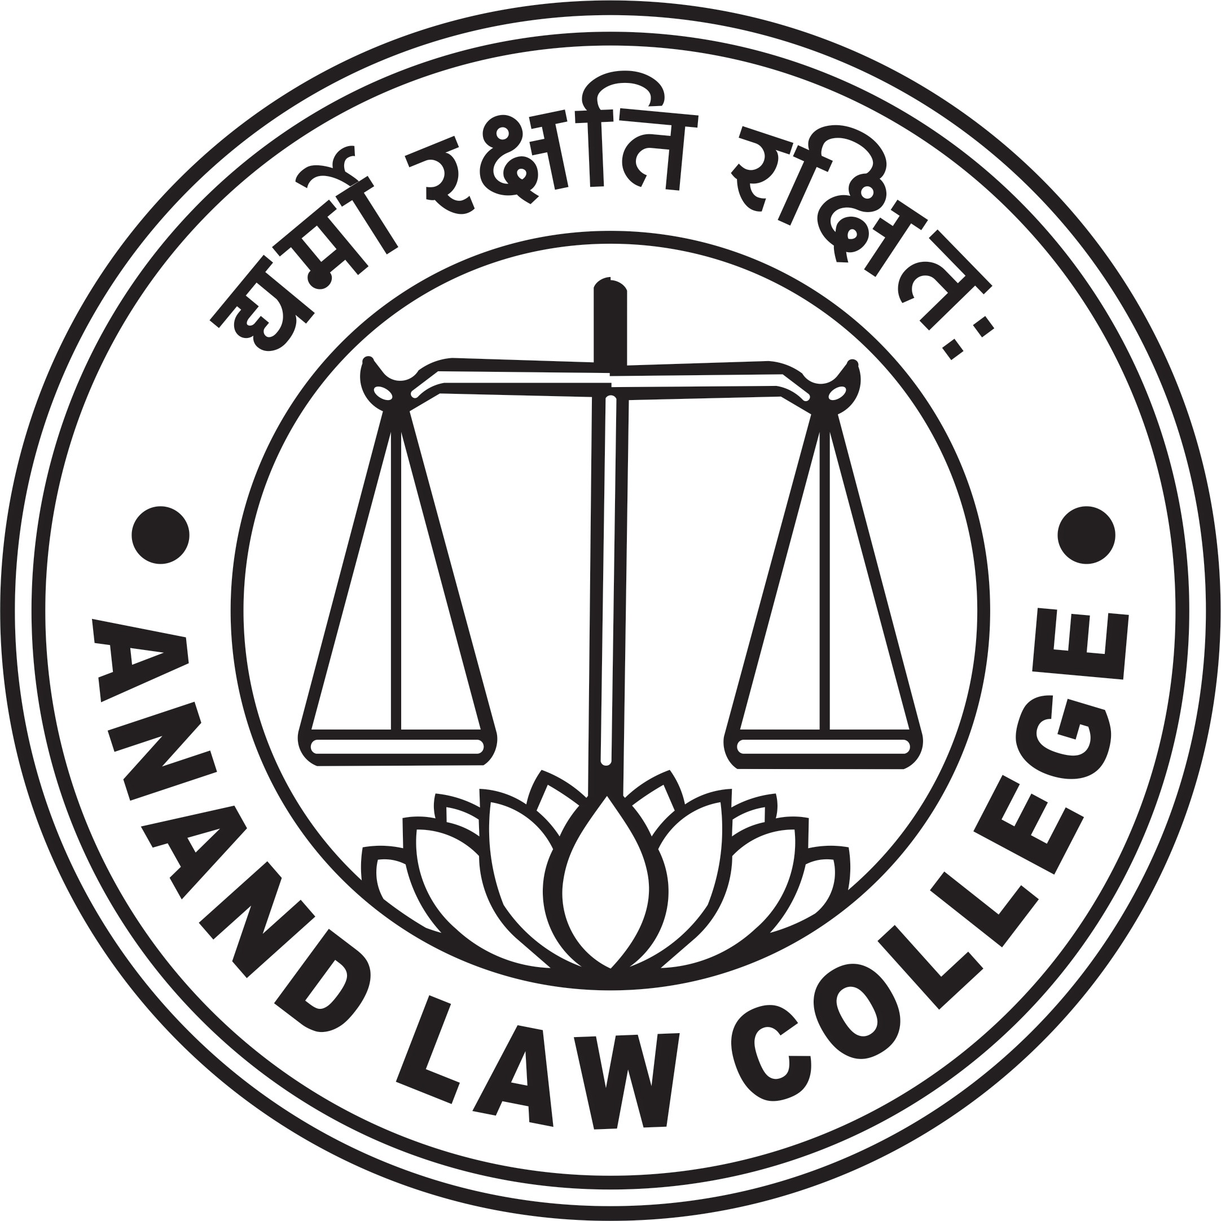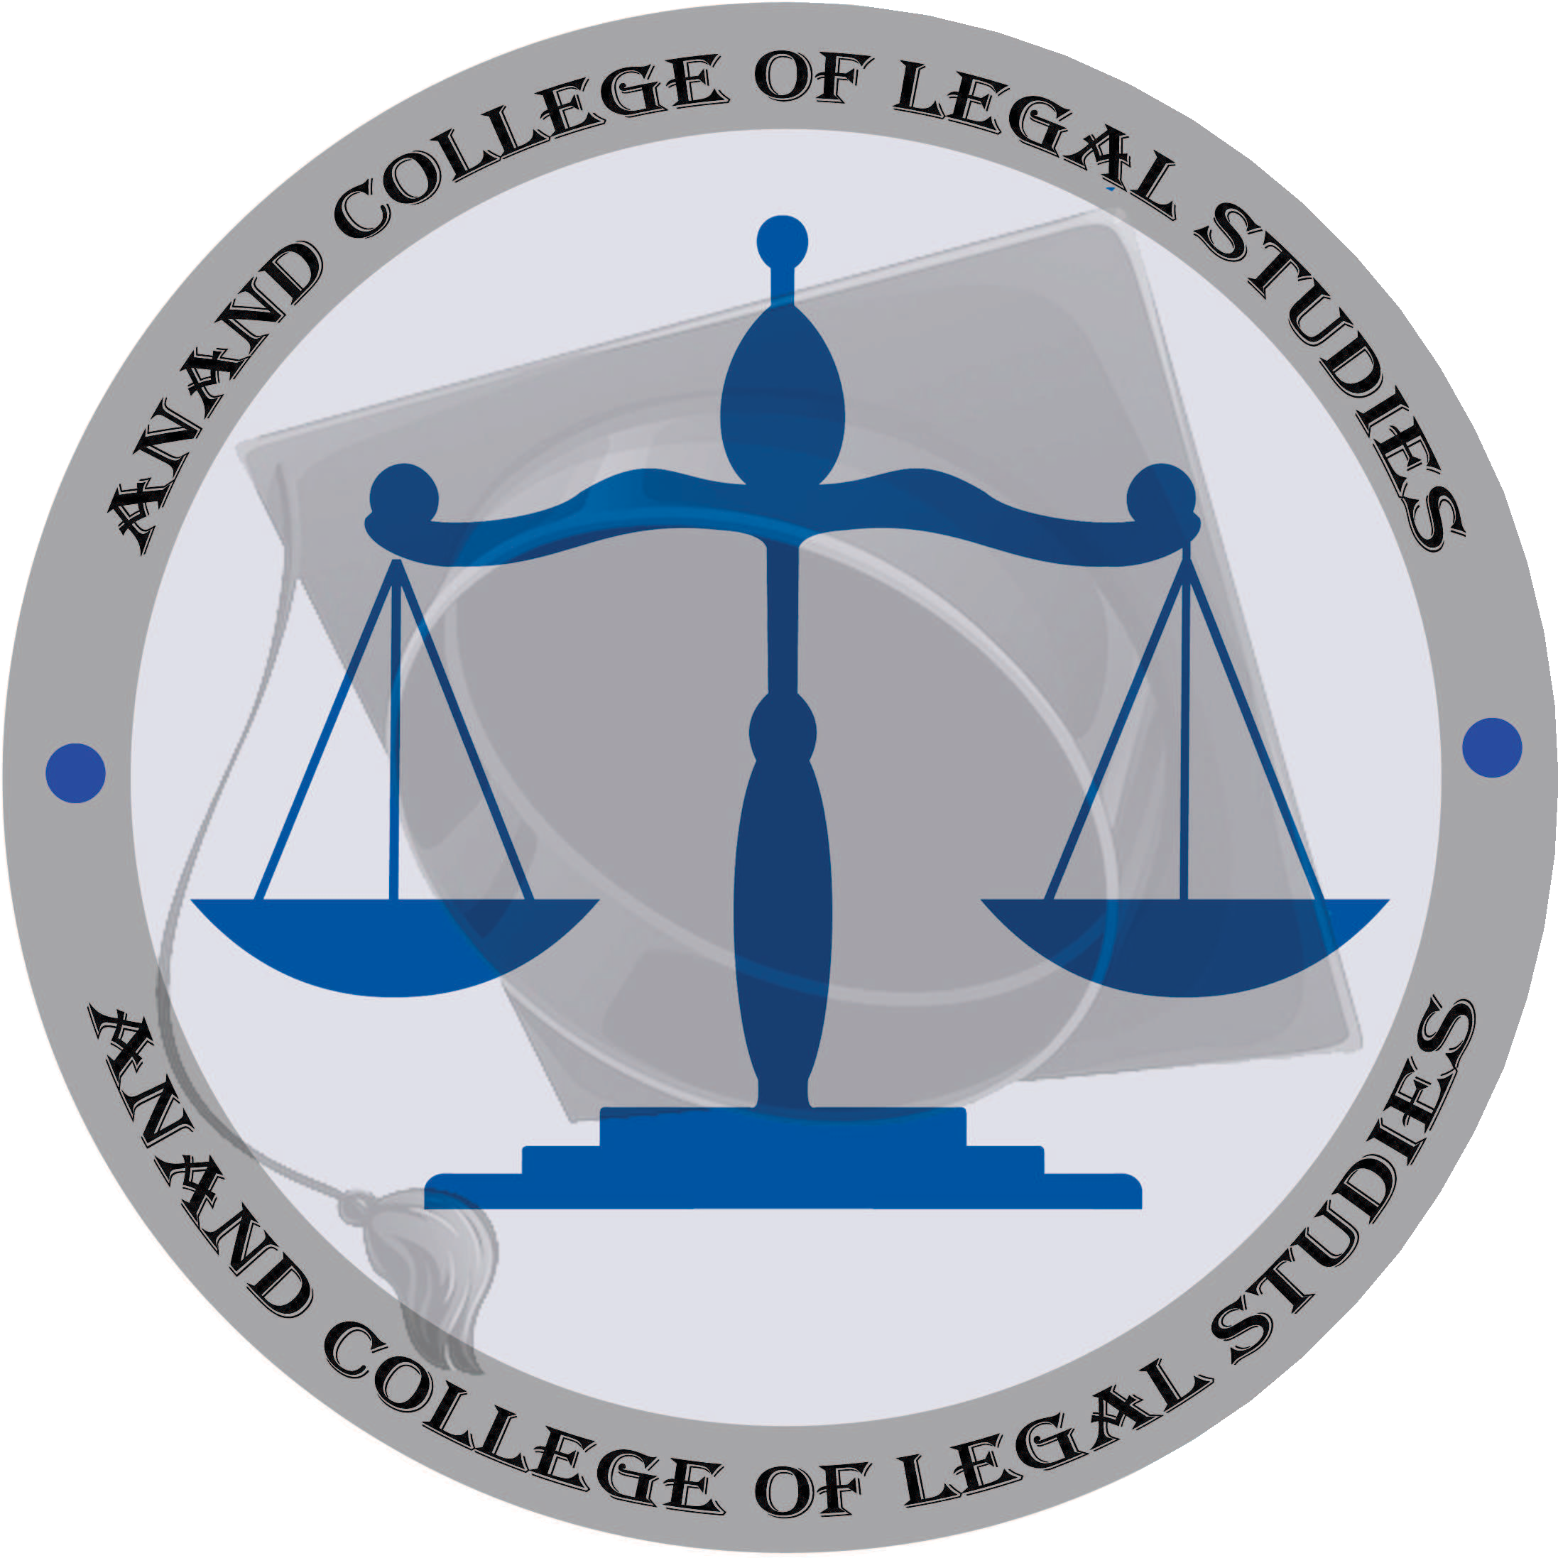Venue: Dr. G. S. Patel Vidhyabhavan & Bhaikaka Hall.

ORGANIZED BY:
Anand Law College & Anand College of Legal Studies (Managed by Shri Ramkrishna Seva Mandal) SRKSM Campus, Near Town Hall, Anand.

Anand Law College
ABOUT COLLEGE

Anand Law College is a legal establishment recognized by the Bar Council of India, New Delhi since 1964 and is motivated by highly enthusiastic professionals under the guidance and supervision of the great visionary Late Dr. Gordhanbhai Shanabhai Patel (Vakil Saheb). The college is managed by Shri Ramkrishna Seva Mandal, Anand and has been rendered an authenticity for permanent recognition to offer various Law Programmes. Its affiliation is with Sardar Patel University, Vallabh Vidyanagar.
Courses Offered: 5-year Integrated Law Courses –B.A.LL.B; & B.B.A.LL.B; Three Year Law Course - LL.B. (CBCS), Master in Law (Business Law), Diploma Courses - D.T.P. & D.L.P.

Anand College of Legal Studies
Anand College of Legal Studies is a legal institution recognized by the Bar Council of India, New Delhi since 2016. College is managed by Shri Ramkrishna Seva Mandal, Anand and has been granted permanent recognition to offer various Law programs. It is affiliated to Sardar Patel University, Vallabh Vidyanagar. ACLS is one of the best law colleges in Gujarat which provides various law courses.
Courses Offered: Three Year Law Course - LL.B. (CBCS), Master in Law (Constitutional Law & Criminal Law)

ABOUT THE SEMINAR
The seminar with the theme and title “Women Empowerment & Inclusive Growth” is proposed to be a National Seminar to be conducted on 7th March 2020 on the International Women's Day. The seminar is aimed at analysing the progress achieved towards the Women Empowerment in particular & inclusive growth in general and also the road ahead in this regard apart from highlighting the challenges & hurdles and suggesting remedial measures in order to achieve women empowerment in India.
The objectives of the seminar are as follows:-
- To analyse the progress achieved towards the goal of women empowerment.
- To highlight the importance of women empowerment in bringing inclusive growth of the country and globally.
- To highlight the existing social legislation, government enactments & policies and gaps in their implementation.
- To identify the road blocks in the path of women empowerment and suggest remedial measures.
- To examine the role of various civic societies and NGOs working in the field of women empowerment.
With the above aim and objectives, the sub themes of the seminar are as follows:-
- Multidimensional issues & Challenges of Women Empowerment.
- Women Empowerment – The key to achieve Economic growth of the country.
- Social legislation, Government policies and enactments to achieve women empowerment.
- Attitude and biased perspective of society – a major hurdle in achieving women empowerment.
- Constitutional Provisions relating to women Empowerment.
- Right to women-Various Laws.

- Role of Judiciary in Empowering Women in India.
- Crimes against women
- Role of civic societies and NGOs in achieving women empowerment in India.
- Women Empowerment essential to Global progress
- International women's Day- its relevance in the Indian Perspective.
Above themes are only illustrative but not exhaustive. The paper presenters may select the related topic covered under the main theme.

Registration Fees:

Delegates | Up to 25thFebruary, 2020 | On the Spot
Faculties, Lawyers, Social  Activists & Others | 500/- | 1000/-
Research Scholars | 300/- | 500/-
Students | 200/- | 250/-
The registration fees have to be sent along with delegate registration form. The registration fees cover- kit, snacks, Tea/coffee and lunch.
Note: Fee does not include accommodation charges. All the payment should be made by demand draft or Cheque. The Cheque/DD should be drawn in favour of ANAND COLLEGE OF LEGAL STUDIES, ANAND.

Call for Papers :
Seminar papers are invited from faculties, lawyers, social activists, research scholars and students on any sub thematic areas or it could be submitted on the main theme in general. All the papers will be submitted to the panel of editorial board to examine originality and contribution to academics.

Guidelines for Paper Submission :
- Research paper presenter is expected to apply research skill and use appropriate research methodology. It is necessary that every paper is confined to thematic or sub-thematic of seminar. It should have proper research questions and also suggest the outcomes of research with the findings. Paper should not contain more than 4000 words.
- It must be typed in Times New Roman Font Size 12 on A4 size paper with 1” margin on all sides with
1.5 line spacing using MS Word. Submission of empirical research paper is appreciated, but researcher is expected to submit analysis of substantive data and sample report.
- Kindly send your abstract or full paper in soft copy/electronic form only on following email id: alcaclsseminar4@gmail.com. Every paper presenter is required to submit an abstract of 350 words with keywords stating the statement of problem, research questions, and methodology applied in the paper with major expected findings.

Seminar Director
Mr. M. B. Prajapati Director, Anand Law College, Anand.

Seminar Convener

Dr. Rekhakumari R. Singh
I/c Principal, ACLS

Dr. Amitkumar I. Parmar
Principal, ALC

Seminar Secretary

Dr. K. C. Bharatiya
Asst. Professor, ALC

Ms. Anjana Solanki
Adhyapak Sahayak, ACLS

Ms. Ankita Patel
Adhyapak Sahayak, ALC

Ms. Darshana Acharya
Asst. Professor, ALC

Organising Committee

·Ms. Pallavi Parmar
·Mr. Ronak Patel
·Ms. Vaishali Joshi
·Ms. Jalpa Shah Mr. Ritesh Suthar
·Dr. Nilesh Shah
·Ms. Aruna Jani
·Mr. Kapil Mehta
·Ms. Nitu Sharma
·Ms. Nikita Raval
·Mr. Ranvirsinh Mahida Ms. Komal Arora

Information Centre

Anand Law College
Ph. (02692) 252034, Fax : 253925
E-mail : office.anandlaw@ymail.com
Anand College of Legal Studies Ph. (02692) 252033,
E-mail : acls.srksm@gmail.com

