N A T I O N A L C O N F E R E N C E O N L A T E S T T R E N D S I N C O R P O R A T E L A W S A N D G O V E R N A N C E R E G I ME
DATE: FEBRUARY 6 & 7, 2020

Sub-themes:

Competition Law
Resolving Cross Border Insolvency Corporate Social Responsibility
Emerging Trends in Cross Border Mergers
Role of Corporate Governance in Addressing the issue of growing Non-performing Assets(NPA)
Defining boundaries of Corporate Governance Significance of Foreign Direct Investment, Foreign Portfolio Investments & Overseas Direct Investment
Shareholders Activism
Aspects of Insider Trading vis a vis SEBI Regulations SEBI vs Union: Autonomy of SEBI Crippled?
Impact of Recession on Corporate Existence

IMPORTANT DATES: -
LAST DATE FOR SUBMISSION OF ABSTRACT & REGISTRATION :20 JANUARY,2020 LAST DATE FOR SUBMISSION OF FULL PAPER:30, JANUARY, 2020
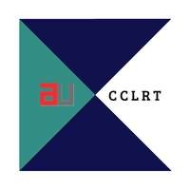Email: cclrt@ansaluniversity.edu.in
Contact: Mr. Vipul Gaur +91-9990123879

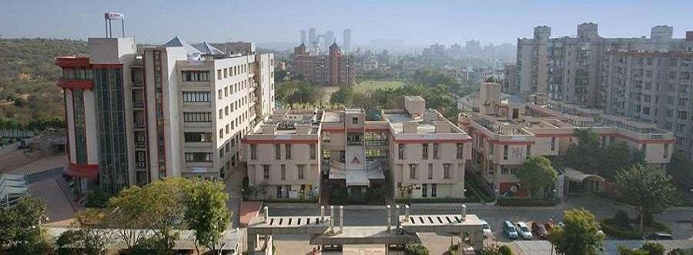

ABOUT ScHOOl of LAW, ANSAl UnivERSITY
School of Law - Ansal University is approved by the Bar Council of India and offers B.A. LL.B. (Hons) and B.B.A. LL.B. (Hons) at the undergraduate level and also one-year LL.M. at the postgraduate level. The School of Law was established at Ansal University in 2014 to impact quality legal education, intending to produce world-class professionals, scholars and academicians in law. The School implements the curriculum through the concept of clinical legal education where the students get an outbound experience of practical nuances of legal profession. The School has continually strived to achieve excellence in legal education through interactive teaching learning process, clinical opportunities and exposures to the legal profession. It encourages the students to be academically sound in an enabling atmosphere conducive to their all-round development.

PeOPLe BEHIND
- Patron
Mr. Shankar Aggarwal, Chancellor, Ansal University, Gurugram.

Chairperson
Prof. (Dr.) Kanu Priya, Associate Dean, School of Law, Ansal University.

Convener
Dr. Komal, Assistant Professor, Centre Head, CCLRT.

Co - Convener
Ms. Vidushi Puri, Assistant Professor, School of Law, Ansal University. Mr. Vipul Gaur, Assistant Professor, School of Law, Ansal University.

Student Convener
Mr. Tarun Kumar, 4th Year, B.A. LL.B.(H)

Student Board
Ms. Ravina Sharma, PhD Scholar, Ansal University Ms. Priyanka Singh, LLM, Ansal University
Ms. Gnanapriya, 4th Year, B.A. LL.B.(H)
Ms. Sonam Mehrotra, 4th Year, B.A. LL.B.(H) Ms. Tripti Kapoor, 4th Year, B.A. LL.B.(H)


ABOUT THE CONFERENCE: -
The dynamics of Corporate world in India are ever evolving. India is one of the fastest- growing economies in the world despite the low growth rates in recent times. The industrial growth is the key for any economy so we need to have balanced growth. Pressure of internationalization, competition, technology advancements, disruptive technology interventions in markets, developments in financial and securities markets, changes in consumer demands all have necessitated regular review and amendments in existing legal framework. Reforms are being made or proposed in every area relating to the corporate world.
The Anti-competitive practices have to be controlled and we need to have healthy competition in the market, this helps in protecting the consumers’ interest, apart from the above issue, various financial scams that are taking place in the recent times, are alarming situations where the law needs to be changed along with the changes.
This is the ripe time for academicians and professionals working in different fields of corporate laws to come together and share their research work on important issues for the benefit of all.
The Centre for Corporate Law, Research and Training (CCLRT) is proposing to hold Two Day National Conference on Corporate Laws on February 6-7, 2020 and invite papers for presentations during the conference.

SUBMISSION GUIDELINES: -
- No Plagiarism shall be allowed.
- Participants have discretion to choose their title however, it must not deviate from the sub-themes provided.
- Abstract Guidelines:
  - The acceptable word limit for the abstract is 300 words. The abstracts whichdo not meet this word limit will be sent back to the author(s) to berevised.
  - Your submission must be in English.
  - We encourage you to send an informative abstract (complete abstract) which is a summary of a paper’s substance including its background, purpose, methodology, results, and conclusion.
  - Please send a brief biography of the author(s) with the Abstract.
- Formatting:
  - Font Type: Garamond
  - Font Size (Headings): 14 Bold
  - Font Size (Sub-headings): 12 Bold
  - Footnotes: 10
  - Line Spacing: 1.5
- Footnoting Style: JILI (Journal of Indian Law Institute) Citation Format
- The paper must have a cover page which must consist:
  - Title of the Paper
  - Name of the Author
  - Affiliated Institution
- Word Limit of the Paper must be 6000 to 8000 words.

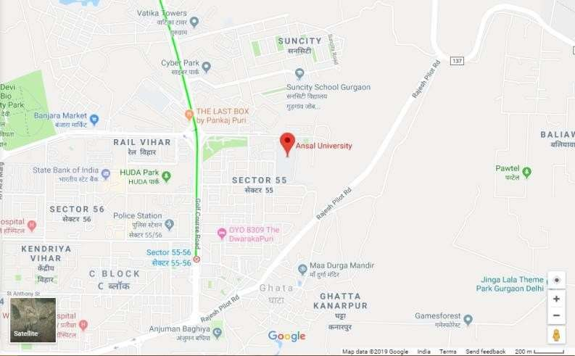REGISTRATION FEES: -
Early Bird (On or before January 20, 2020): -
Ansal University Students: 500/- per author
Other Students/Research Scholars: 1000/- per author.
After January 20, 2020
Ansal University Students: 1000/- per author. Students/Research Scholars: 1500/- per author. Professionals/Academicians/Others: 2000/- per author.
**Co-authorship of only one person is allowed.
Note: -
- No accommodation facility available.
- Skype presentations or presentations in absentia are not allowed.
- Bank details for Online Transaction: - Account Name- Ansal University Bank Name- Yes Bank Ltd. Account Number- 000380200001999 IFSC Code- YESB0000003
Bank Address- Plot No. 11/48, Diplomatic Enclave, Malcha Marker, Chanakyapuri, New Delhi – 110021
- Please fill the registration form prior to sending any details/full paper/abstract - https://forms.gle/igC67Z2QuXwD3L119
- Please mail the Abstract and Research Paper in .docx format only, along with the registration fee submission details, after the completion of the registration process to – cclrt@ansaluniversity.edu.in

CO-CONVENER
Mr. Vipul Gaur - +91-9990123879
STUDENT CONVENER
Mr. Tarun Kumar - +91-9958987622
##Selected research papers will be published with a leading publisher.
University Address: -
Ansal University, Sector 55, Golf Course Road, Gurugram, Haryana – 122003

