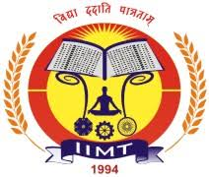
NATIONAL CONFERENCE
ON
UNIFORM CIVIL CODE: WHETHER IT IS DEMAND OF TIME? –
“ISSUES & CHALLENGES”
(18-19 FEBRUARY, 2020)
Organised by
IIMT COLLEGE OF LAW, GREATER NOIDA
Plot No. 20-A, Knowledge Park-III, Greater Noida, Uttar Pradesh – 201310, India
&
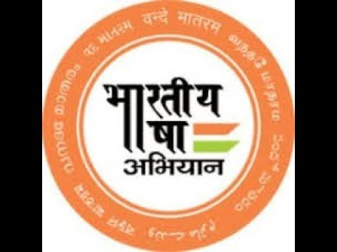
BHARTIYA BHASHA ABHIYAN, NEW DELHI

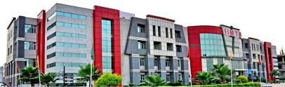
ABOUT IIMT
IIMT Group of Colleges came into existence in 1994. The College has inherited a bounteous legacy of quality education propounded by our great sages and scientists, and has earned exemplary recognition in all walks of life such as corporate world, academics and social life. It aims at providing global education infused with core moral values. The IIMT Group runs several professional programmes such as LLB, BA.LLB, Management, Mass Communication, Pharmacy, Law and B.Ed. Moreover, the Group envisions getting status of global academic institution through innovations and research emphatically focused on burning issues as well.
ABOUT THE CONFERENCE
IIMT College of Law, Greater Noida is organising a National Conference with Bhartiya Bhasha Abhiyan (Shiksha Sanskriti Uthan Nayas, New Delhi) on UNIFORM CIVIL CODE: WHETHER IT IS DEMAND OF TIME? – “ISSUES & CHALLENGES”
Uniform Civil Code has become a burning topic in India with the recent alteration in Triple Talaq and Article 370. In gleam of this, IIMT College of Law endeavour to provide venture for Academicians, Advocates, Research Scholars and Students to discuss and present their views pertaining to Uniform Civil Code.

SUB-THEMES
- Uniform Civil Code: Need & Importance
- Uniform Civil Code: Constitutional Provisions
- Uniform Civil Code and Triple Talaq
- Jurisprudence on Uniform Civil Code
- Uniform Civil Code vis- a- vis Personal Laws
- Uniform Civil Code & Judicial Mandate
- Uniform Civil Code and Gender Parity
- Secularism Versus Uniform Civil Code
GUIDELINES
Abstract:
Interested authors may submit an abstract of their original unpublished Research Papers in about 200-300 words, typed in Times New Roman, font Size 12 on A4 size paper with 1” margin on all sides with 1.5 line spacing using MS Word. All abstracts will be peer reviewed and evaluated before final acceptance. Authors of accepted abstracts will be invited to submit and present full paper at the conference.

Full Paper:
The length of full papers should not exceed 4000 words (excluding tables, figures and references etc.) and it should not be less than 2000 and formatting should be Times New Roman, font Size 12 on A4 size paper with 1” margin on all sides with 1.5 line spacing & font size 10 for footnoting. use MS Word only and follow Bluebook 20th Edition.
General Guidelines
- Papers should be written in English or Hindi.
- Co-authorship is permitted.
- Multiple submissions will lead to disqualification.
- No part of the paper should have been published earlier nor should it be under consideration for publication. Plagiarism should not be more than 10%.
- Registration will be confirmed on or before 27th January 2020 only on payment of registration fees.
- Registration Form: https://forms.gle/8uwCDoZH735RBhuq8
- Two printed copy of the paper should be submitted at the registration desk on 18 February 2020.
- Candidates who requires accommodation shall fill in the Accommodation form and email it with full paper on or before 05th February, 2020.
- Accommodation are limited. They will be provided on the basis of first come first serve.
- Publication fees will be separate, Publication includes one copy of Book having ISBN number & Certificate of publication.
IMPORTANT DATES
HEADS | LAST DATES
Abstract Submission | 25th January, 2020
Abstract Acceptance | 27rd January, 2020
Full Paper Submission | 05th February, 2020
Conference | 18-19 February, 2020
REGISTRATION FEES
CATEGORIES | FEES (IN RUPEES)
Academicians/Advocates | 800
Research Scholars | 600
Students (UG & PG) | 400
Co-Author (Separate registration) | 250
MODE OF PAYMENT
GOOGLE PAY – 8317082623
UPI- visheshbhardwaj1995@oksbi
ACCOUNT DETAILS
Name of Account: IIMT COLLEGE OF LAW
Bank Name: YES Bank
IFSC Code: YESB0000226
Account No. 022694600000523
PUBLICATION
CATEGORIES | FEES (IN RUPEES)
Author | 500
Co-author | 500

ACCOMMODATION
Accommodation is available within IIMT College of Law Campus on Payment of Rs.500 per day/ per person (includes food and lodging).
Accommodation form : https://forms.gle/tD1u82FLBP4TdfAq6
PATRON CONVENER
Shri. Mayank Aggarwal Dr. Pankaj Dwivedi
(Managing Director) (Director)
(IIMT Group of Colleges) (IIMT College of Law)
CO-CONVENERS
Advocate Arun Bhardwaj Mr. Vishesh Bhardwaj
Bhartiya Bhasha Abhiyan Asst. Professor, IIMT College of Law
New Delhi (+91- 8317082623)

Advocate Kameshwar Nath Mishra Mrs. Kaushiki Roy
Bhartiya Bhasha Abhiyan Asst. Professor, IIMT College of Law
New Delhi (+91-9555384501)
ORGANISING SECRETARIES
Mr. R.K. Jolly Mr. Prashant Mavi Mr. P.K. Sharma
CO- ORGANISING SECRETARIES
Dr. Dheerendra Singh Mr. Sailesh Tripathi
SCRUITNEY COMMITTEE
Dr. Monika Rastogi Dr. Rama Rani Dr. M.K. Sharma
MEMBERS
Mr. Manish Kr. Attry Mr. Rajendra Kumar Mr. Amrit Lal
Mr. R.D. Singh Yadav Mr. R.K. Singh Mrs. Jyoti Verma
Mrs. Swapnil Pandey Mrs. Aparna Singh

ADVISORY COMMITTEE
- Shri. Sanjay Swami, Delhi State Convener, Shiksha Sanskriti Utthan Nyas, New Delhi).
- Prof. Anand Paliwal (Head & Dean, Department of Law, Mohanlal Sukhadia, University, Udaipur, Rajasthan).
- Prof. R.K. Chaubey (Dean, Faculty of Law, University of Allahabad, U.P).
- Prof. Vibha Tripathi (Faculty of Law, Banaras Hindu University, UP).
- Prof. R. K. Singh (Head & Dean, Punjabi University, Patiala)
- Dr. Kameshwar Prasad (Associate Professor, CCS University, Meerut)
- Prof. Rakesh Singh (Head & Dean, Faculty of Law, Lucknow University)
- Prof. R.K. Mittal, (Vice Chancellor, Chaudhary Bansilal University, Bhiwani, Haryana).
- Dr. Dinesh Kumar, (Vice Chancellor, IASE, Gandhi Vidhya Mandir, Sardarshahar, Rajasthan).
- Mr. Sachidanand Prasad, Bhartiya Bhasha Abhiyan, Jharkhand.
- Mr. Raghavendra Shukla, Bhartiya Bhasha Abhiyan, Uttar Pradesh.
- Mrs. Poonam Gaur, Bhartiya Bhasha Abhiyan, Delhi.
- Mr. Ajit Pathak, Bhartiya Bhasha Abhiyan, Bihar.
- Mrs. Nirmala Nayak, Bhartiya Bhasha Abhiyan, Madhya Pradesh.
- Mrs. Archana Sharma, Bhartiya Bhasha Abhiyan, Uttar Pradesh.

