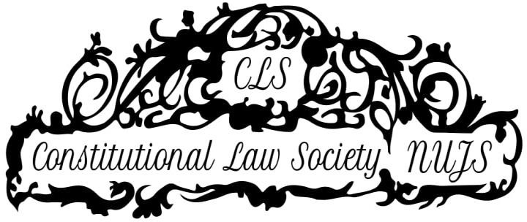

EIGHTH DURGA DAS BASU ESSAY WRITING COMPETITION

December- January, 2019 - 2020

Organised by the Constitutional Law Society under the aegis of West Bengal National University of Juridical Sciences, Kolkata
TOPIC: “The debate between the Duty to respect the National Flag and the Anthem versus using them as symbols of protest.”

ABOUT CLS

The Constitutional Law Society (‘CLS’) is an academic society which was constituted in 2012 by interested students and our faculty advisor, the former Vice-Chancellor, to assist the understanding of Constitutional Law. Its objective is to further knowledge and create a supportive environment for academic discussions and thought about constitutional matters. The CLS that has successfully organised several events, including quizzes, mock parliaments, lectures and discussions by eminent scholars on topics of constitutional law of contemporary as well as historic relevance. We are associated with the D.D. Basu Trust which organises an annual essay writing competition, currently in its 8th edition and an endowment lecture, currently in its 13th edition. Similarly, the M K Nambyar Lecture is also organised by the CLS, currently in its 8th edition. In the past, we have hosted luminaries in the field such as K.K. Venugopal, Upendra Baxi, and Catherine MacKinnon among others.

ABOUT THE D. D. BASU ESSAY COMPETITION

The Durga Das Basu Essay Competition held in memory of the eminent jurist and lawyer Shri Durga Das Basu (1910-1997). Dr. Basu was a distinguished Judge of Calcutta High Court. His Commentary on the Constitution of India, written over twenty years ago is still used extensively as the primary treatise on constitutional law. Dr. Basu was awarded the Padma Bhushan in 1985. Every year, contemporary topics of constitutional significance are chosen for annual Essay Writing Competition. The themes in the previous years have ranged from the role played by constitutional conventions in India to the use of constitutional power to disqualify a person from contesting democratic elections. This year, the topic has been chosen against the backdrop of the need for promotion of the Fundamental Duties present in our Constitution.

RULES
- The competition is open for all undergraduate students of law colleges/departments of law of all Universities, pursuing the 5-year-course or the 3-year-course. Co-authorship (of a maximum of two authors) shall be allowed. The co-authors may belong to different Universities. There can be more than one participant/s from any University.
- There is no registration fee.

- The formatting specifications are:

  - Font: Time News Roman `
  - Font Size: 12
  - Spacing: 1.5
  - Margin: One inch on all sides
  - Paper size: A4
  - Minimum Word Limit – 4000, Maximum word Limit - 5000 (including footnotes, kindly avoid using speaking footnotes).
- Citations are mandatory and should be in the form of footnotes following a uniform format. The NUJS Law Review Standard of citation must be adhered to. http://nujslawreview.org/wp-content/uploads/2016/10/NUJS-Citation-Standard-1st- Edition.pdf

- All submissions will undergo strict online plagiarism check.

- No identification mark should be found on any part of the submission.
- Special consideration will be placed upon originality, applicability and feasibility of the arguments/ suggestions made in the essay and the depth of research.
- The copyright in the legislative draft submitted by the participating teams shall vest with the Constitutional Law Society. Further, The Constitutional Law Society shall not be responsible for any liability accrued to any person or for any loss caused to any person because of the content of the legislative draft submitted.
- In case of any dispute, the decision of the Directors of the Constitutional Law Society and National University of Juridical Sciences will be final.
- All teams/ participants must send electronic copies of their essays in “.docx” (Microsoft Word) and “.pdf” formats by email to ddbasuessaywritingcompetition@gmail.com by 11:59 PM on January 25th 2019. No extension with respect to the deadlines will be granted.
It is the responsibility of each Team to ensure that the “.docx” copy of the submission can be opened legibly with Microsoft Office 2010 or Microsoft Office 2007 and the “.pdf” copy of the submission can be opened legibly with Adobe Acrobat Reader.
- The “subject” of the submission email should clearly mention “Submission for DD Basu Essay Writing Competition 2019.”
Participants shall also clearly mention their names, phone numbers, addresses and name of their College/ University, and course undertaken along with their year of study clearly in the body of the email.
- Prizes to be awarded:

First place: Rs 5000 and merit certificate Second place: Rs 3000 and a merit certificate Third place: Rs 2000 and a merit certificate No participation certificates will be issued.
- The essays of all the winners of the prizes would be published on the NUJS CLS blog https://wbnujscls.wordpress.com
- Please visit the page of the NUJS Constitutional Law Society page www.facebook.com/ConstitutionalLawSocietyNujs for updates about the competition.
- For inquiries, email us at nujs.cls@gmail.com.

